**Just Getting By?

Get Ahead Instead.

The goal of this 16 session program is to increase ALL of your resources, build confidence, increase opportunities for personal growth and to gain support from others who are on a similar path. We are currently seeking parents of school age children who are seeking to improve their and their families lives. Some limited transportation assistance may be available. **Ashtabula County residents only.**

New program starting: September 4, 2018- 11:30 am - 2:30 pm

Meets Twice Weekly: Tuesdays and Thursdays

Location: Ashtabula County YMCA, 263 W. Prospect Rd., Ashtabula, Ohio

***\*\* CHILDCARE PROVIDED **LIGHT MEAL AT THE PROGRAM** PAID EACH SESSION***

**MUST APPLY, BE ACCEPTED AND COMPLETE REGISTRATION PRIOR TO START DATE!**

SPACE IS LIMITED- CALL FOR MORE INFO!

Lois Miller- Martone - Catholic Charities of Ashtabula County

440-992-2121

loismm@doyccac.org

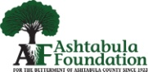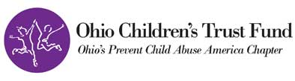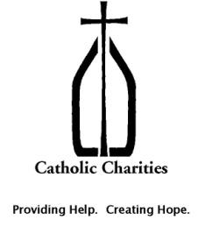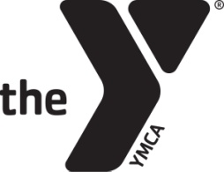 Funding for this initiative provided in part by: