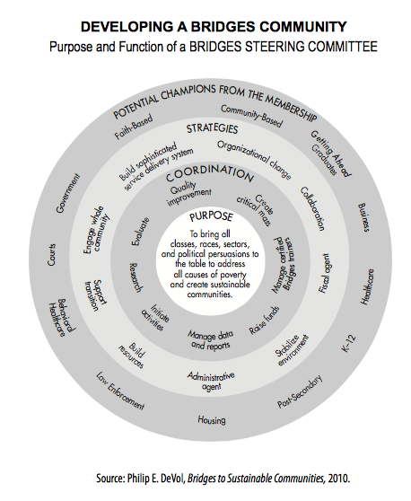

Member name here

Member name here

Member name here

Member name here

Member name here

Member name here

Member name here

Member name here

Member name here

Member name here

Member name here

Member name here

Member name here

Member name here

Member name here

Member name here