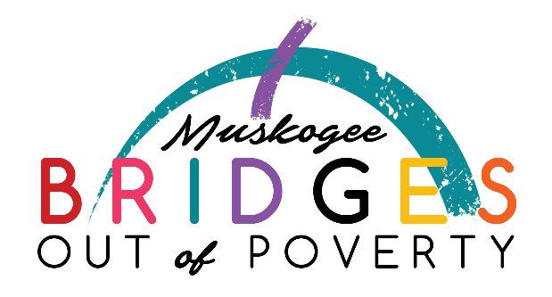
Bridges Steering Committee Meeting
Nonprofit Resource Center
July 25, 2017
5:30pm Meeting
AGENDA
Prayer
New and Goods
Approval of May Meeting Notes
Sub-committees reports:
1) Drug Court 3) Transportation/Car Donation Program
2) Fines/Fees for Felons 4) Language Barrier
5) Legal Assistance Program
Updates:
GA Classes
GO Classes
Financial Literacy Classes
Food Team
Childcare/Khan Academy
Dental/Vision Team
Marketing
BOP Trainings
Director’s Report
New Business
Round Table
Adjourn
Next Meeting: August 22, 2017 at 6:00 pm at St. Paul

