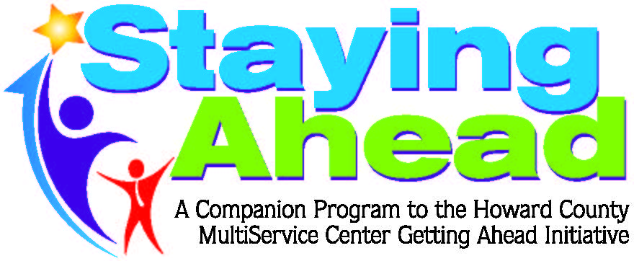

Workshops
Financial Literacy Workshops with Roy Yenoli and Nora Wood as facilitators every 3rd Thursday, 5:30 p.m.- 7p.m. at Howard County Central Library- dates: 8/17, 9/21, 10/19, and 11/16
To register please contact: Valerie Mathis, 410-313-0242. vmathis@howardcountymd.gov

