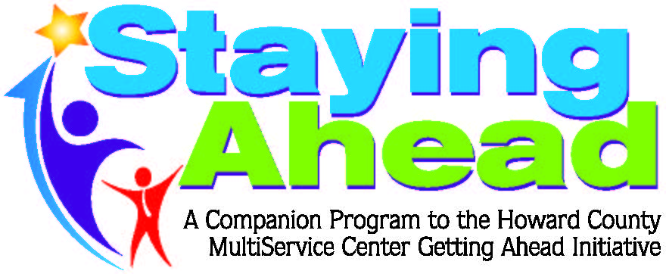

Entrepreneurship Workshop hosted by Brooke Abercrombie, 5p.m.-6:30 p.m. at the following locations:
• September 7-Central Library
• October 19- Miller Library

To register please contact Valerie Mathis, 410-313-0242, vmathis@howardcountymd.gov

