

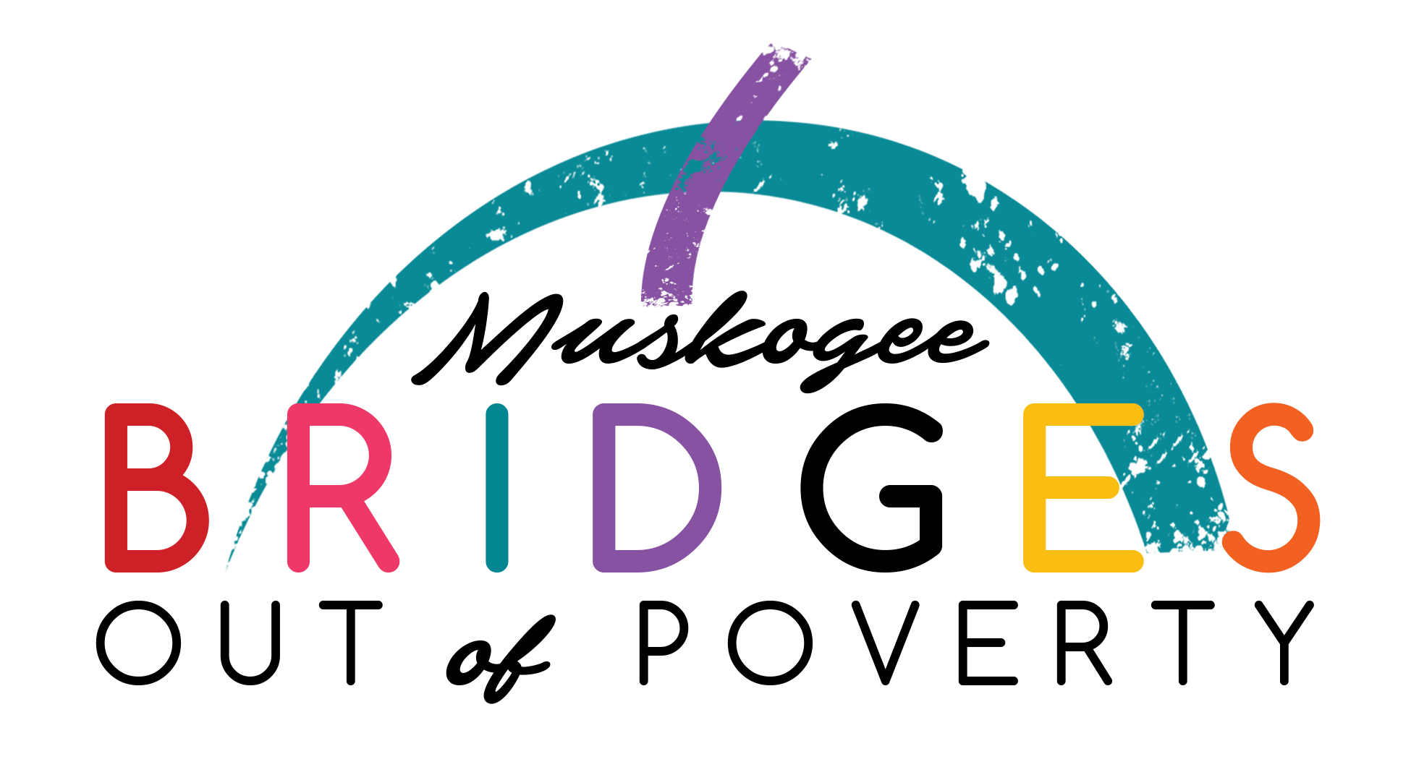

invites you to attend the  
 **“Getting Ahead” Class Social & Dinner**  
**Tuesday, May 16, 2017**  
St. Paul United Methodist Church  
2130 W. Okmulgee  
5:30pm    
   
Designed to allow Getting Ahead Class “Investigators”   
and alumni to build their social network of business contacts.      
This informal social time is invaluable to the participants   
as we strive to bridge the gap between community leaders   
and the under resourced population.    
  
  
The current class will have their  
**“Getting Ahead” GRADUATION**

**Tuesday, May 23, 2017**   
St. Paul United Methodist Church  
6:15pm    
Join us to show community support   
as they celebrate this major accomplishment.  
  
  
RSVP to Shenia or Diana at 918.683.4600  
by Monday May 15 at 5:00pm for both.