Named the  2016 National  Bridges Out Of Poverty Community of  the Year!  Muskogee Oklahoma is accomplishing the impossible – reducing generational poverty.  Muskogee has become a national model for success in moving the needle on poverty.  Contact Us:  Muskogee Bridges Out Of Poverty  Nonprofit Resource Center  207 N. 2nd Street  Muskogee, OK 74401  918-683-4600  muskogeebridgesoutofpoverty.org  www.nbn-nrc.org |  |  | Muskogee Bridges Out Of Poverty Nonprofit Resource Center  207 N. 2nd Street  Muskogee, OK 74401 |  | - 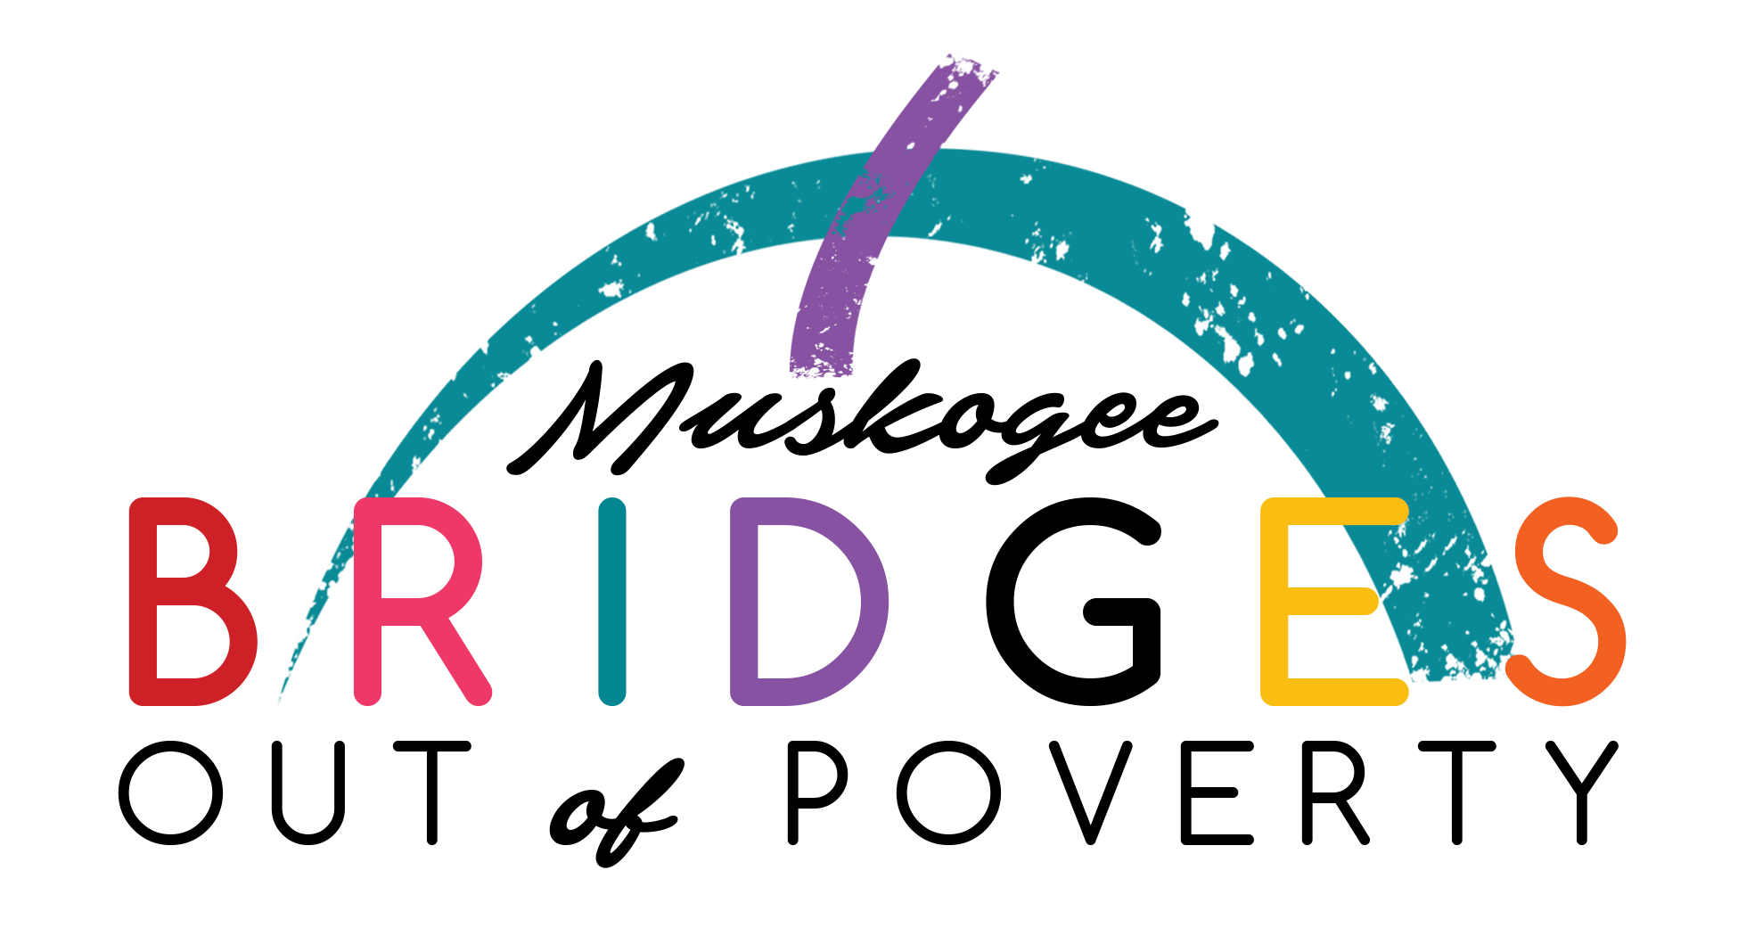Empowering People with Resources & Hope  Getting Ahead in a  Just Gettin’ By World Classes  Helps people in poverty reach their  full potential by changing their mindset and increasing their resources.  Empowers them to investigate the barriers that keep them from  getting ahead.  Bridges Out of Poverty  Workshops  Educates the whole community on the complexities of poverty.

Details:  - 20 Weeks  - One Night a Week (Tuesday)  - 5:30pm – 8:30pm  - Meal Provided  - Educational Childcare Provided  - Small Class Sizes  - Guest Speakers  - Graduation Ceremony  - Spanish Speaking Class Available  Requirements:  - Below 200% of the Federal Poverty Level  - Not on disability assistance  - Not currently in a major crisis  - Must have a Muskogee address  Asf | “This class helped me see how to get out of the rut I was in and create permanent changes for my future”  – Mary H.  (Getting Ahead Graduate)  Getting Ahead In a Just Gettin’ By World Class  What Will You Learn:  - What is generational poverty  - What’s keeping you in generational poverty  - How to transition to self-sufficiency  - How to examine your life  - How to identify available resources  - How to create a plan for a better future  - How to increase your social resources  - To receive a renewed sense of HOPE  How to get Started:  - Submit an application  - Attend an in person interview  - Commit to 20 weeks of classes  - Be willing to work with others to become self-sufficient, i.e. independent of public assistance |  | Bridges Out Of Poverty Workshops  Workshop Details:  - No Charge  - 3 Hours in length  - Any location  - Based on Ruby Payne’s book  - Case studies  - Detailed analysis  - Funny stories  - Fun exercises  - Real solutions  - Discover why “middle class” solutions to poverty don’t produce the results we’re looking for and what works  Volunteer Opportunities  Resource Partner for Graduates  - Food Prep/Serving Team  - Clean-Up Team (30 Minutes)  - Childcare Team  - Providing A Meal (Food or $200)  Funded By:  The City of Muskogee Foundation  Private Donations  Host Partner:  Saint Paul’s United Methodist Church

